Write a C program to simulate Real-Time CPU Scheduling
algorithms:
- Rate- Monotonic

Algorithm

Input: n tasks
Each task i has:
Ci → execution time
Ti → period
Step 1: Calculate CPU Utilization
U = 0
for i = 1 to n:
U = U + (Ci / Ti)
Step 2: Calculate RMS Bound
bound = n * (2^(1/n) - 1)
Step 3: Check Schedulability
if U &lt;= bound:
print &quot;Schedulable using RMS&quot;
else:
print &quot;Not guaranteed schedulable (need further analysis)&quot;
Step 4: Assign Priorities
Sort tasks in ascending order of period (Ti)
// Smaller period → higher priority
Step 5: Scheduling Loop
while system is running:
select highest priority task that is READY
execute task
if a higher priority task arrives:
preempt current task
execute higher priority task

#include <stdio.h>
struct process {
int id, burst, period, remaining;
};
int main() {
int n, time = 0, completed = 0;
printf("Enter number of processes: ");
scanf("%d", &n);
struct process p[n];
for(int i = 0; i < n; i++) {
p[i].id = i + 1;
printf("\nProcess %d\n", i + 1);
printf("Execution Time: ");
scanf("%d", &p[i].burst);
printf("Period: ");
scanf("%d", &p[i].period);
p[i].remaining = p[i].burst;
}
printf("\nScheduling Order (RMS):\n");
while(completed < n) {
int idx = -1;
int min_period = 9999;
for(int i = 0; i < n; i++) {
if(p[i].remaining > 0 && p[i].period < min_period) {
min_period = p[i].period;
idx = i;
}
}
if(idx != -1) {
printf("Time %d: P%d\n", time, p[idx].id);
p[idx].remaining--;
time++;
if(p[idx].remaining == 0)
completed++;
} else {
time++;
}
}
return 0;
}
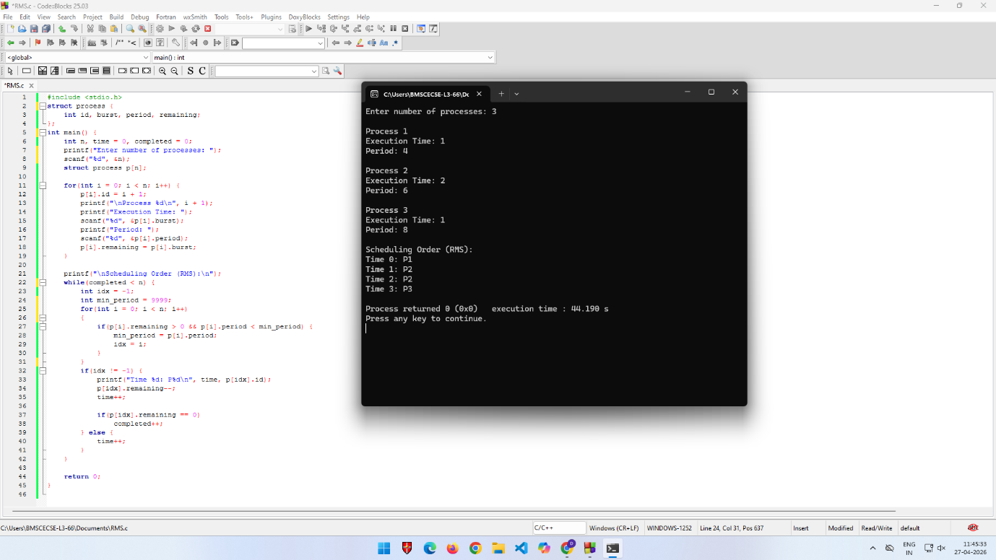

- Earliest-deadline First

Algorithm

1. // Step 1: Compute CPU Utilization
2. U = 0
3. for each process Pi in Process_List:
4. U = U + (Ci / Di)
5. // Step 2: Feasibility Check
6. if U &gt; 1:
7. print &quot;Scheduling not feasible (deadlines may be missed)&quot;
8. else:
9. print &quot;Scheduling feasible&quot;

10. t = 0 // current time
11. while (there are unfinished processes):
12. Ready_List = {Pi | Arrival_Time(Pi) ≤ t AND Pi not completed}
13. if Ready_List is empty:
14. t = t + 1
15. continue
16. // Step 3: Select process with earliest deadline
17. P = process in Ready_List with minimum deadline
18. // Step 4: Execute (preemptive)
19. run P for 1 time unit
20. remaining_time(P) = remaining_time(P) - 1
21. if remaining_time(P) == 0:
22. mark P as completed
23. t = t + 1
24. end while

#include <stdio.h>
struct process {
int id, burst, deadline, remaining;
};
int main() {
int n, time = 0, completed = 0;
printf("Enter number of processes: ");
scanf("%d", &n);
struct process p[n];
for(int i = 0; i < n; i++) {
p[i].id = i + 1;
printf("\nProcess %d\n", i + 1);
printf("Execution Time: ");
scanf("%d", &p[i].burst);
printf("Deadline: ");
scanf("%d", &p[i].deadline);
p[i].remaining = p[i].burst;
}
printf("\nScheduling Order (EDF):\n");
while(completed < n) {
int idx = -1;
int earliest_deadline = 9999;
for(int i = 0; i < n; i++) {
if(p[i].remaining > 0 && p[i].deadline < earliest_deadline) {
earliest_deadline = p[i].deadline;
idx = i;
}
}
if(idx != -1) {
printf("Time %d: P%d\n", time, p[idx].id);
p[idx].remaining--;
time++;
if(p[idx].remaining == 0)
completed++;
} else {
time++;
}
}
return 0;
}

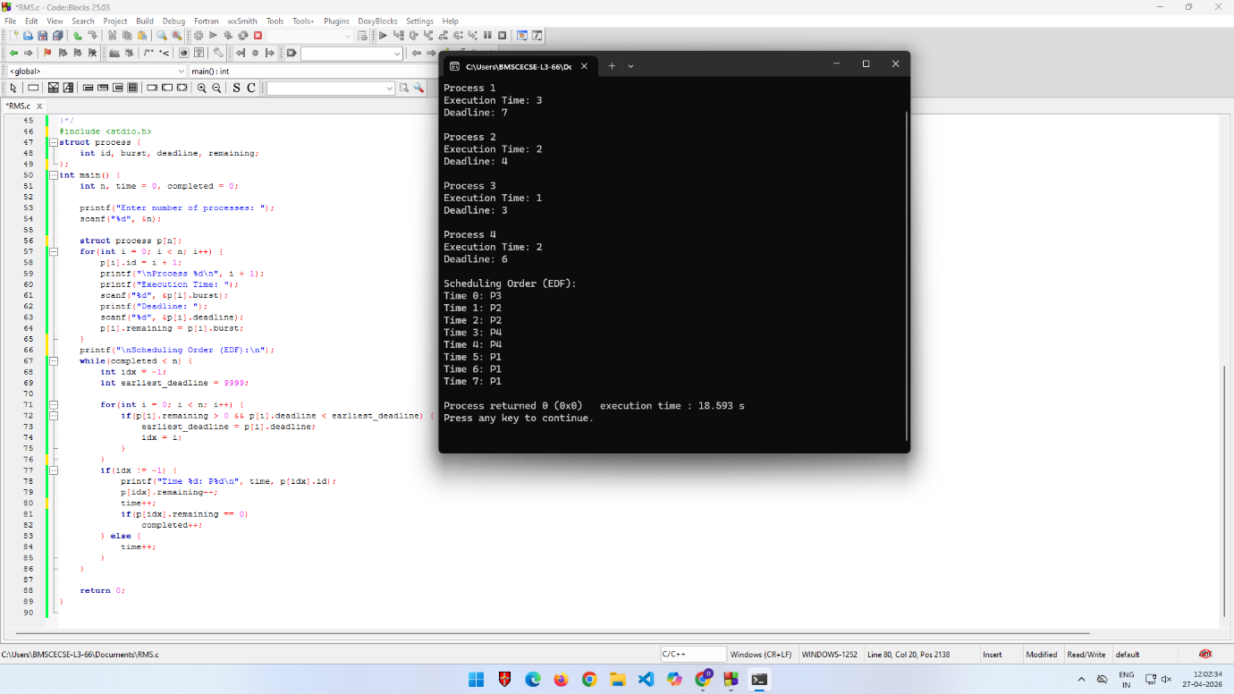

- Proportional scheduling

Algorithm

1. total_weight = 0
2. for each process Pi in Process_List:
3. total_weight += weight[i]
4. while (there are unfinished processes):
5. for each process Pi in Process_List:
6. if Pi is ready:
7. // calculate time slice proportional to weight
8. time_slice[i] = (weight[i] / total_weight) * TIME_QUANTUM
9. run Pi for time_slice[i]
10. remaining_time[i] - = time_slice[i]
11. if remaining_time[i] &lt;= 0:
12. mark Pi as completed
13. total_weight - = weight[i]
14. end while

#include <stdio.h>
struct process {
int id, burst, weight, executed;
};
int main() {
int n, total_weight = 0, time = 0, completed = 0;
printf("Enter number of processes: ");
scanf("%d", &n);
struct process p[n];
for(int i = 0; i < n; i++) {
p[i].id = i + 1;
printf("\nProcess %d\n", i + 1);
printf("Execution Time: ");
scanf("%d", &p[i].burst);
printf("Weight (Share): ");
scanf("%d", &p[i].weight);
p[i].executed = 0;
total_weight += p[i].weight;
}
printf("\nScheduling Order (Proportional Share):\n");
while(completed < n) {
for(int i = 0; i < n; i++) {
if(p[i].executed < p[i].burst) {
printf("Time %d: P%d\n", time, p[i].id);
p[i].executed++;
time++;
if(p[i].executed == p[i].burst)
completed++;
}
}
}
return 0;
}

